MIMIC methodology

1. In patients having open heart surgery after they have left the operating room, what is the last measured red cell level (expressed as hemoglobin and typically abbreviated as Hb) before the first blood transfusion is given?

1. First of all, for patients undergoing open heart surgery, their hadm_id should meet the three conditions of seq_num being 1, icd_code starting with 361, and admission type not URGENT, EM EMER or DIRECT EMER. Next, to ensure that the time was after they left the operating room, all measured times needed to be after the most recent time extracted from the outtime stored in mimic-core-transfers table with careunit as cardiac surgery.

2. Extract the blood transfusion measurement information from the mimic-icu-inputevents table, join with the mimic-icu d_items and with the label packed red blood cells, and select the measurements with the earliest time of each hadm_id as the first blood transfusion

3. Hemoglobin measurement information is extracted from two sources in mimic, one is stored in the mimic_hosp_labevents table, join with mimic_hosp_d_labitems labeled as hemoglobin, and the other from mimic_icu_charevents, join with mimic_icu_d_items also labeled as hemoglobin. However, most of them are duplicates. Calculate the time difference between each hemoglobin measurement and the first blood transfusion for each hadm_id, and select the last measured hemoglobin before the first blood transfusion based on the hemoglobin measurement before the first blood transfusion and the minimum time difference.

4. There are some strange values that the hemoblobin measurement measured at the same time but with quite different value(shown at figure), the value was replace by the mean of that value(shown at figure).

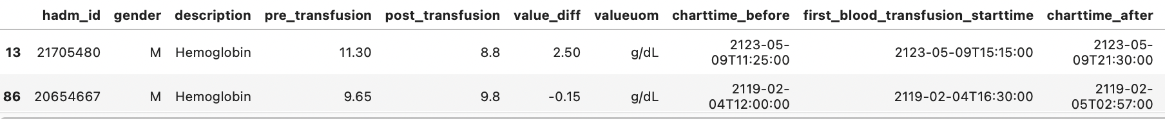

1. , . In patients having open heart surgery,  after have left the operating room, when the first act of blood transfusion is performed, how many units of blood (also called red cells or packed red cells)  are given?

The blood transfusion volume is stored in the totalamount column, and the totalamountuom storage unit is ml

1. . In patients having open heart surgery after they have left the operating room, what is the last Hb before a blood transfusion is given in men compared with women?

It is similar to get last hemoblobin as discussed above, but last hemoblobin for all blood transfusion rather only first blood transfusion.

Gender information is stored in the mimic_core.patients table, and in order to add gender information to the hemoglobin measurement, the hemoglobin measurement is conditionally joined with the mimic_core.patients table on the same subject_id.

4.In patients having open heart surgery, after they have left the operating room what is the difference between the first Hb after the blood was given and the last Hb before the blood was given?

1.First, all blood transfusion measurement information of the CABG cohort was obtained and to obtain the time difference between hemoglobin measurement and blood transfusion.

2. The time difference between each hemoglobin measurement and the first blood transfusion for each blood transfusion time. The The last Hb before transfusion is given by the hemoglobin measurement that occurred at the shortest time before the transfusion, and the first Hb after the blood was given by the measurement of hemoglobin that occurred at the shortest time after the transfusion. The difference between them is simply calculated by subtracting the last Hb from the first Hb.

3.Gender information is stored in the mimic_core.patients table, and in order to add gender information to the hemoglobin measurement, the hemoglobin measurement is conditionally joined with the mimic_core.patients table on the same subject_id.

4.There are some strange values occurred in hemoglobin measurement(shown in figure ) that multiple measurement at the same time but with quite different values and deal with same strategy above meansion to take their average to replace

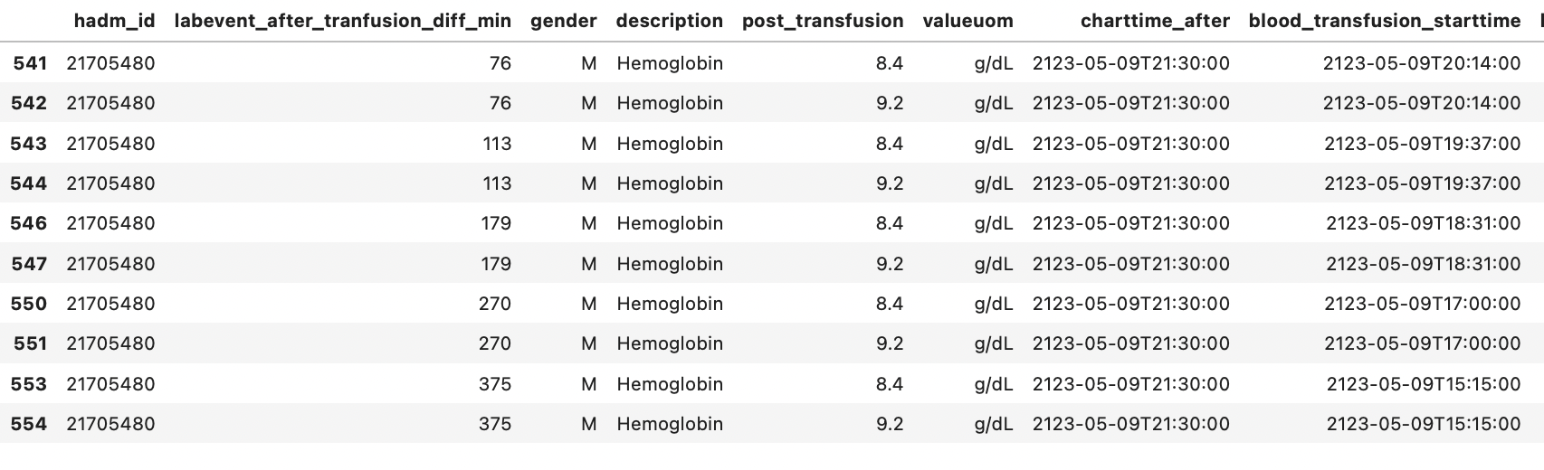

## 1. How many times the hg was measured right from the beginning of the surgery to the first 24 hours of the intensive care

1.First, obtain all hemoglobin measurements for the CABG cohort.

2 In order to meet the measurement requirements within 24 hours before intensive care, the hemoglobin measurement time need be earlier than the earliest intime plus 24 hours that extracted from intime stored in mimic-core-transfers table with careunit as cardiac surgery

3.Then group by hadm_id to counts the number of filterd hemoglobin measurements for each hadm_id.